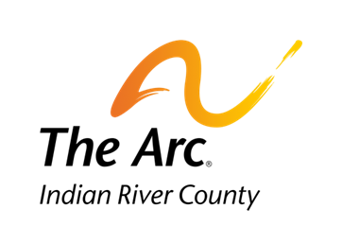

1375 16th Avenue, Vero Beach, Florida 32960
772.562.6854
www.arcir.org

Job-A-Palooza Business Interest Form

Name of Business:
Primary Contact:
Contact Phone: Email:

Description of Task(s) for Job-A-Palooza:

Would you contact The Arc in the future if you had available jobs that might of interest to our clients?

Business Representative Signature Date

