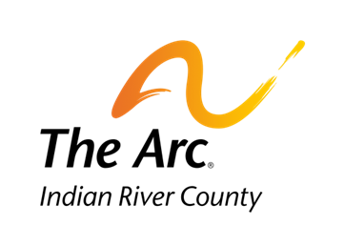

1375 16th Avenue, Vero Beach, Florida 32960
772.562.6854
www.arcir.org

Job-A-Palooza Peer Mentor Interest Form

Name of Peer Mentor:
Primary Contact:
Contact Phone: Email:

Have you had experience working with or mentoring a person with special needs?
If so, in what capacity and for how long:

At job-a-palooza your responsibilities would be:
- Be familiar with the tasks you will be assisting them with
- Practice the task with the student
- Encourage the student to do their best

Thank you for being a Peer Mentor and Making and difference in someone’s life!

Peer Mentor Signature Date

