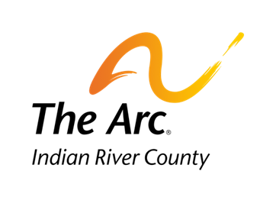

1375 16th Avenue, Vero Beach, Florida 32960
772.562.6854 www.arcir.org

Job-A-Palooza Student Interest Form
MUST BE TURNED IN NO LATER THAN AUGUST 24, 2018
Students with Disabilities with a 504 or IEP and are
between the ages of 14 and 21 are eligible for this program.

Name of student:
Primary Contact:
Contact Phone: Email:

Are you interested in learning new work skills?
If so, what types of jobs are you interested in:

What you will do at Job-A-Palooza:
- Choose 5 businesses (tasks) to compete in with their peer mentor.
- Tasks will be detailed for each business similar to a “Task Analysis” and posted so all students are familiar with the requirements.
- Students will fill out both a pre-event and post-event questionnaire.
- This form must be completed and turned in prior to the event to be registered.
- The Vocational Rehabilitation registration form MUST be turned in either before or the day of the event.
Lunch will be provided. Please list any dietary restrictions you may have.

Student Signature Date

